CCP – Report



Group Members:
Mifrah Iqbal (CT-172)
Sadia Amir (CT-157)
Sana (CT-174)
Team Name: Syntax Squad
Course: Programming Fundamentals (CT-175)
Instructor: Sir Muhammad Abdullah
Date: 13th November 2025
Sr. No. |  |  | Section | Page No.
1 |  |  | Project Title | 3
2 |  |  | Abstract | 3
3 |  |  | Introduction | 4
4 |  |  | Technical Terms & Concepts | 5
6 |  |  | Problem Statement | 5
7 |  |  | System Design & Implementation | 6
8 |  |  | System Architecture | 7
9 |  |  | Code | 12
10 |  |  | Result | 17
11 |  |  | Testing & Result | 18
12 |  |  | Future Work | 19
13 |  |  | Conclusion | 20
14 |  |  | Thanks | 21

PROJECT TITLE

Student Course Registration System

Abstract
This project presents a simple yet efficient Course Registration System developed in the C programming language. The system allows students to manage their academic course selections through an interactive, menu-driven interface. It provides users with multiple functionalities such as viewing available courses, registering for desired courses, dropping previously selected courses, viewing a list of currently registered courses, and checking total registered credit hours.
The program maintains data in arrays for quick access and uses control structures like loops and conditionals to handle user inputs dynamically. The implementation emphasizes logical problem-solving, array handling, and real-time user interaction in a console-based environment. The system continuously runs until the user chooses to exit, ensuring smooth operation and easy management of course data. This project demonstrates fundamental programming concepts such as arrays, loops, condition checking, and input/output handling while simulating a real-world student course management process.
.

Introduction
In any academic institution, course registration is an essential process that enables students to select the subjects they wish to study for a particular semester. Traditionally, this process can be complex and time-consuming. The goal of this project is to design a simple and interactive Course Registration System using the C programming language to automate and simplify this process.This program allows students to view a list of available courses, each associated with a unique ID and credit hours. Students can register or drop courses by entering the corresponding course IDs. The system keeps track of all registered courses using an array, ensuring that users cannot register for the same course twice or drop a course they have not taken. Additionally, it maintains a running total of the credit hours based on the registered courses, allowing students to monitor their workload easily.
The project employs key programming concepts such as:
- Arrays to store course details and registration status,
- Loops to create a continuous, interactive menu system,
- Conditional statements to handle user choices and prevent invalid inputs,
- Variables and arithmetic operations to track and update total credit hours dynamically.
Overall, this project showcases how basic C programming constructs can be effectively combined to develop a practical and user-friendly system. It provides a solid foundation for beginners learning about structured programming, control flow, and data management in C

Technical Terms and Concepts
Course Management Module:
Displays all available courses along with their course IDs and assigned credit hours. Manages course details such as names, credit values, and total count using arrays.
• Registration Module:
Allows students to register for selected courses by entering the corresponding course ID. Updates registration status and adds respective credit hours to the total credit count
.• Course Drop Module:
Enables users to drop previously registered courses. The module updates the registration status and deducts the related credit hours from the total.
• User Interaction Module:
Provides a menu-driven interface using a continuous loop. Accepts user choices and executes corresponding actions such as course registration, course drop, or viewing credits.
• Credit Hour Tracker:
Calculates and maintains the total number of credit hours based on registered courses. Updates dynamically whenever a course is added or dropped.
• Course Status Tracking:
Uses an integer array to monitor which courses are registered (1) and which are not (0). Ensures accurate tracking of the student’s current enrollment status.
• Input/Output Management:
Uses standard C library functions (printf() and scanf()) for communication with the user. Handles menu display, input collection, and result presentation efficiently.
• Validation and Error Handling:
Ensures data accuracy by checking for invalid course IDs, duplicate registrations, or attempts to drop unregistered courses. Displays meaningful error messages to guide the user.
• Data Storage (Arrays & Pointers):
Stores course names using character pointers (char *names[]) and uses integer arrays for credits and registration flags. Demonstrates static data management in memory.
• Loop and Control Logic:
Implements an infinite while(1) loop to keep the program running until the user exits. Uses if-else structures to direct control flow based on user choices.
• Program Termination Module:
Ends program execution when the user selects the exit option. Uses the break statement to stop the infinite loop and prints a closing message.

Problem Statement
The main objective of this project is to develop a simple and user-friendly course registration system using the C programming language. The system allows students to easily view available courses, register for desired courses, and drop courses when needed. It dynamically tracks the total credit hours of registered courses and prevents duplicate or invalid registrations through input validation. Additionally, the project demonstrates fundamental C programming concepts such as arrays, loops, and conditional statements, providing a practical example of how structured programming can be applied to solve real-world academic problems.

System Design and Implementation
7.1 Data Structure
    - Primary Structure Used
Course Arrays and Registration Array
The system primarily uses arrays to store course-related data and student registration details. These arrays act as the core dataset for the program
- names[5] — stores the names of available courses.
- hrs[5] — stores the credit hours for each course.
- reg[5] — tracks student registration status (0 for not registered, 1 for registered).
These arrays collectively represent the operational dataset for the course registration process.
7.1.2 Dataset Description
Even though this is a small-scale, non-database project, the system internally manages a dataset of 5 courses:

Course Details:
- Course IDs: 1–5
- Names: Programming Fundamentals, Islamiyat, Maths, English, Applied Physics
- Credit Hours: Predefined for each course (2–3 credits)
- Registration Status: Initially 0 (not registered)
Each array element stores all necessary information about a course and student registration status, forming the complete dataset used during program execution.
7.2 System Modules / Implementation Flow
The Course Registration System is designed as a menu-driven application with multiple functional modules. Each module performs a specific task and interacts with the main dataset (arrays) to manage course registration efficiently.
7.2.1 Course Management Module
- Displays all available courses with their corresponding course IDs and credit hours.
- Allows students to view details before making registration decisions.
- Uses the names[] and hrs[] arrays for data retrieval.
7.2.2 Registration Module
- Allows students to register for a course by entering its course ID.
- Updates the reg[] array to mark the course as registered (1).
- Adds the respective course credit hours to the total credit count.
- Validates input to prevent duplicate registration or invalid course IDs.
7.2.3 Course Drop Module
- Enables students to drop a previously registered course.
- Updates the reg[] array to mark the course as not registered (0).
- Deducts the corresponding credit hours from the total.
- Ensures that only registered courses can be dropped, with proper error handling.
7.2.4 Registered Courses Module
- Displays all courses that a student is currently registered for.
- Checks the reg[] array to identify active registrations.
- Provides feedback if no courses are registered.

7.2.5 Credit Tracker Module
- Maintains a running total of credit hours based on the registered courses.
- Updates dynamically whenever courses are added or dropped.
- Helps students monitor their academic load efficiently.
7.2.6 Input/Output Module
- Handles all user interactions through console-based input (scanf) and output (printf).
- Provides a menu-driven interface that loops until the student chooses to exit.
- Validates user inputs and displays error messages for invalid entries.
7.2.7 Program Termination Module
- Ends program execution gracefully when the student selects the exit option.
- Prints a closing message confirming program termination.

7.3 Flow Diagram / Flowchart Description
The flow of the Course Registration System is organized to ensure smooth user interaction and accurate course management. The system operates in a menu-driven loop where each user choice triggers a specific module.
Flow Description:
- Start Program:
  - The system initializes all arrays: course names, credit hours, and registration status.
  - Total credit hours are set to 0.
- Display Main Menu:
  - Options include: Show Courses, Register Course, Drop Course, My Courses, Total Credits, Exit.
  - The student is prompted to enter a choice.
- User Input Validation:
  - Checks if the input corresponds to a valid menu option (1–6).
  - If invalid, an error message is displayed, and the menu is shown again.
- Module Execution Based on Choice:
  - Show Courses: Displays all available courses and their credit hours.
  - Register Course: Registers a course if not already registered, updates reg[], and adds credits.
  - Drop Course: Drops a registered course, updates reg[], and deducts credits.
  - My Courses: Displays all currently registered courses.
  - Total Credits: Shows the total registered credit hours.
  - Exit: Terminates the program gracefully.
- Loop Back:
  - After executing a module (except Exit), the system returns to the main menu.
  - Ensures continuous interaction until the student chooses to exit.
- Program Termination:
  - When the exit option is selected, a closing message is displayed.The program ends, preserving all operations performed during the session
  - Program Workflow
Start System
↓
Initialize Courses, Credit Hours, and Registration Array
↓
Display Menu
↓
User Selects an Option
↓
Case Handling:

Case 1: Show Courses
- Display all available courses with credit hours

Case 2: Register a Course
- Ask for Course ID
- If valid and not already registered:
- Mark course as registered
- Add credit hours to total
- Show success message
- Else show error message

Case 3: Drop a Course
- Ask for Course ID
- If valid and already registered:
- Mark course as not registered
- Subtract credit hours from total
- Show success message
- Else show error message

Case 4: My Courses
- Display all registered courses
- If none, display "No courses registered yet."

Case 5: Total Credits
- Display total registered credit hours

Case 6: Exit
- Show exit message
- Terminate program

Default:
- Invalid choice message

↓
Return to Menu (loop continues until Exit)

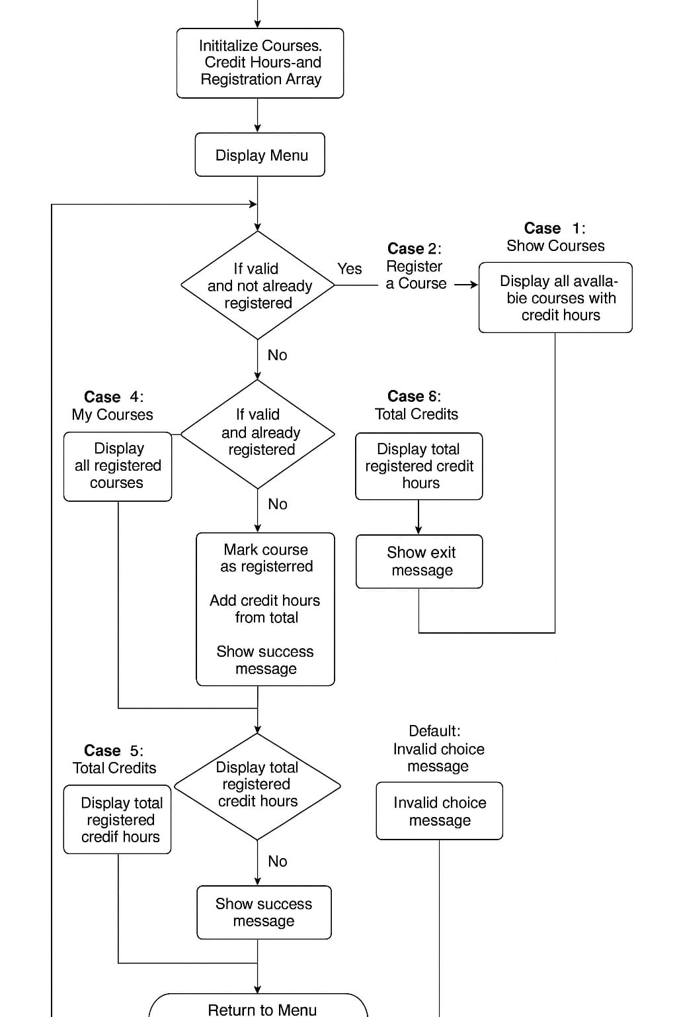
Code
#include <stdio.h>

int main() {
int choice, id, credits = 0;
int reg[5] = {0};
registered courses (0 = not registered, 1 = registered)
int hrs[5] = {3, 2, 2, 3, 3};
char *names[5] = {
"Programming Fundamentals",
"Islamiyat",
"Maths",
"English",
"Applied Physics"
};

while (1) {
// Display menu
printf("\n=== COURSE REGISTRATION ===\n");
printf("1. Show Courses\n");
printf("2. Register a Course\n");
printf("3. Drop a Course\n");
printf("4. My Courses\n");
printf("5. Total Credits\n");
printf("6. Exit\n");
printf("Enter your choice: ");
scanf("%d", &choice);

// Show all available courses
if (choice == 1) {
printf("\nAvailable Courses:\n");
for (int i = 0; i < 5; i++) {
printf("%d. %s - %d Credits\n", i + 1, names[i], hrs[i]);
}
}

// Register a course
else if (choice == 2) {
printf("Enter Course ID to register (1-5): ");
scanf("%d", &id);

if (id < 1 || id > 5) {
printf("Invalid Course ID!\n");
}
else if (reg[id - 1] == 1) {
printf("You are already registered for this course!\n");
}
else {
reg[id - 1] = 1;
credits += hrs[id - 1];
printf("Course registered successfully!\n");
}
}

// Drop a course
else if (choice == 3) {
printf("Enter Course ID to drop (1-5): ");
scanf("%d", &id);

if (id < 1 || id > 5) {
printf("Invalid Course ID!\n");
}
else if (reg[id - 1] == 0) {
printf("You are not registered for this course!\n");
}
else {
reg[id - 1] = 0;
credits -= hrs[id - 1]; // Subtract credit hours
printf("Course dropped successfully!\n");
}
}

// Show registered courses
else if (choice == 4) {
int none = 1;
printf("\nRegistered Courses:\n");
for (int i = 0; i < 5; i++) {
if (reg[i] == 1) {
printf("%d. %s\n", i + 1, names[i]);
none = 0;
}
}
if (none) {
printf("No courses registered yet.\n");
}
}

// Show total credits
else if (choice == 5) {
printf("Total Credit Hours: %d\n", credits);
}

// Exit program
else if (choice == 6) {
printf("Exiting program. Thank you!\n");
break;
}

// Invalid choice
else {
printf("Invalid choice! Please try again.\n");
}
}

return 0;
}

Results and Assumptions
Results
When executed, the program:
- Displays all available courses with credit hours.- Allows students to register or drop courses.
- Displays a list of registered courses.
- Calculates total credit hours automatically.

Assumptions
- There are only 5 courses.
- Each course has a unique ID (1–5).- User enters valid numeric input.
- Credit hours remain constant.

Future Work

1. Add a student database for multiple users.
2. Use file handling to save and load registration data.
3. Add login authentication for each student.
4. Include error handling for invalid inputs.
5. Develop a graphical (GUI) version for better usability.

Conclusion
The Course Registration System is a user-friendly and efficient solution for managing student course enrollment. By providing functionalities such as course listing, registration, dropping courses, and tracking total credit hours, the system ensures a seamless and organized approach to course management. Its interactive menu-driven interface allows students to perform tasks easily while maintaining data integrity through proper validation checks. Overall, this system enhances the registration experience, minimizes errors, and serves as a practical tool for academic administration, demonstrating the effective use of C programming concepts such as arrays, loops, conditional statements, and user input handling.

